Basic query, filtering, dan aggregation:
- Berapa jumlah total trip valid pada Januari 2026?
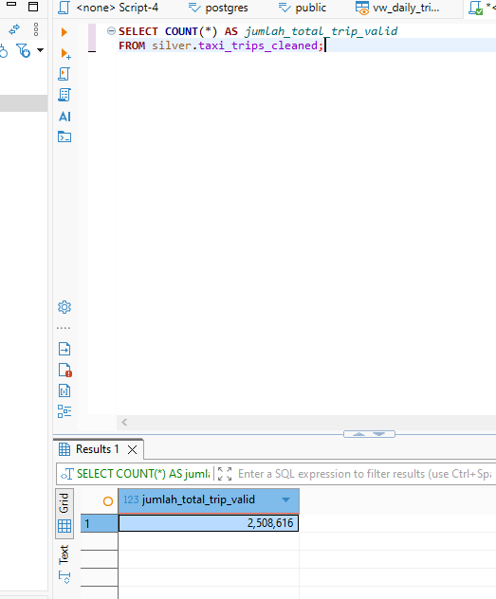
- Berapa total revenue, average revenue, average fare, dan average tip?
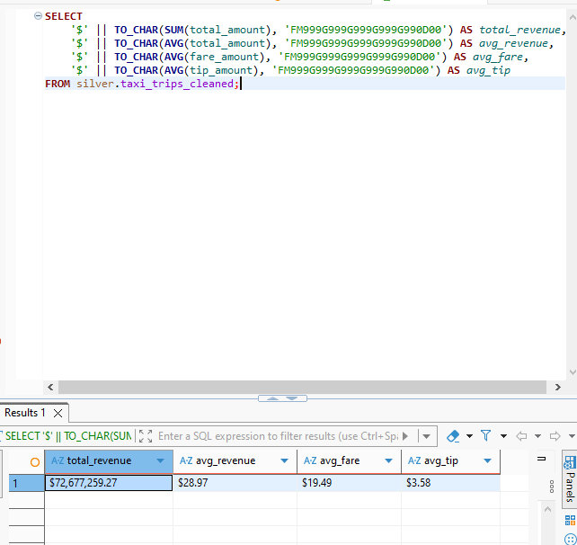

- Tanggal atau jam apa yang memiliki jumlah trip tertinggi?
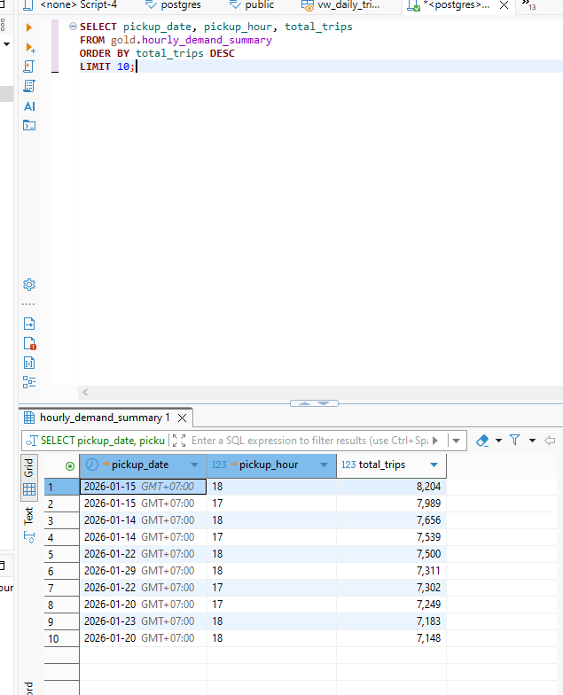
- Bandingkan jumlah trip weekday dan weekend.
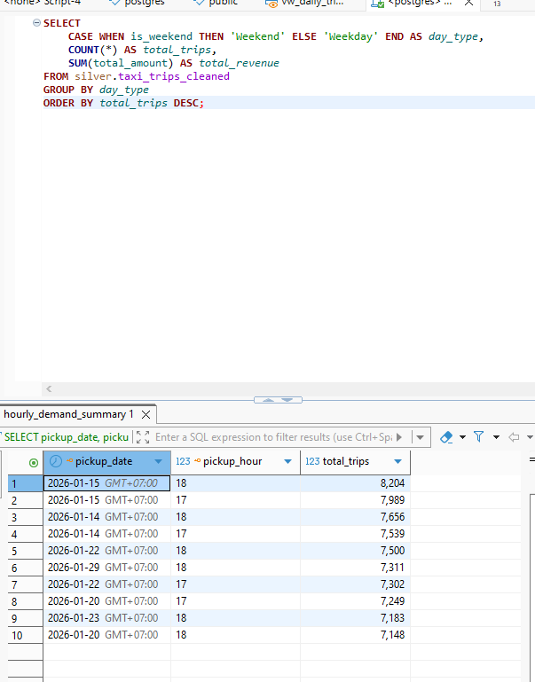
5. Payment type apa yang paling sering digunakan?
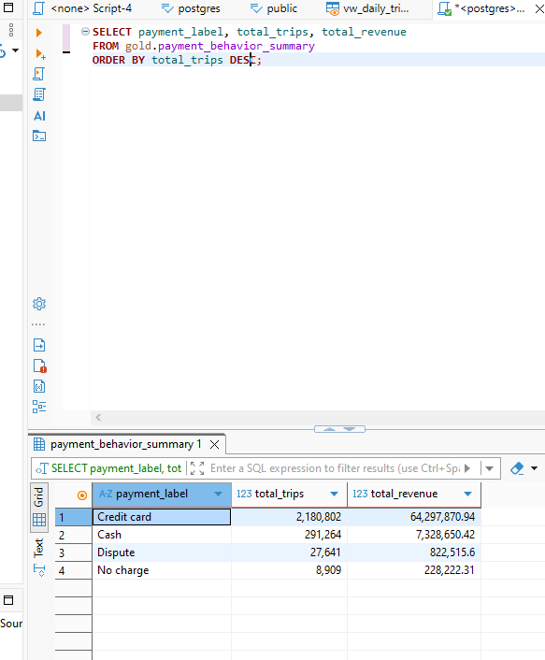

Join dan location analysis:
6. Borough atau zone pickup mana yang memiliki jumlah trip tertinggi?
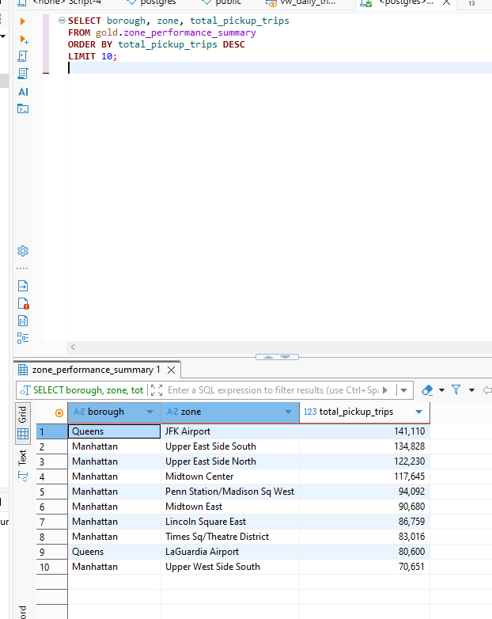

7. Zone pickup mana yang menghasilkan total revenue tertinggi?
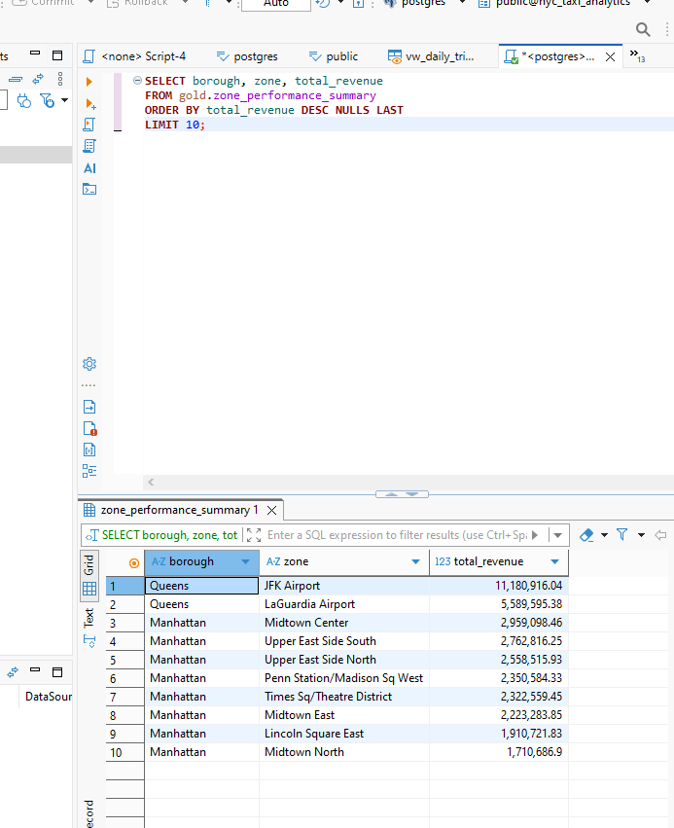

8. Rute pickup zone ke dropoff zone mana yang paling sering terjadi? Date, time, dan data quality:

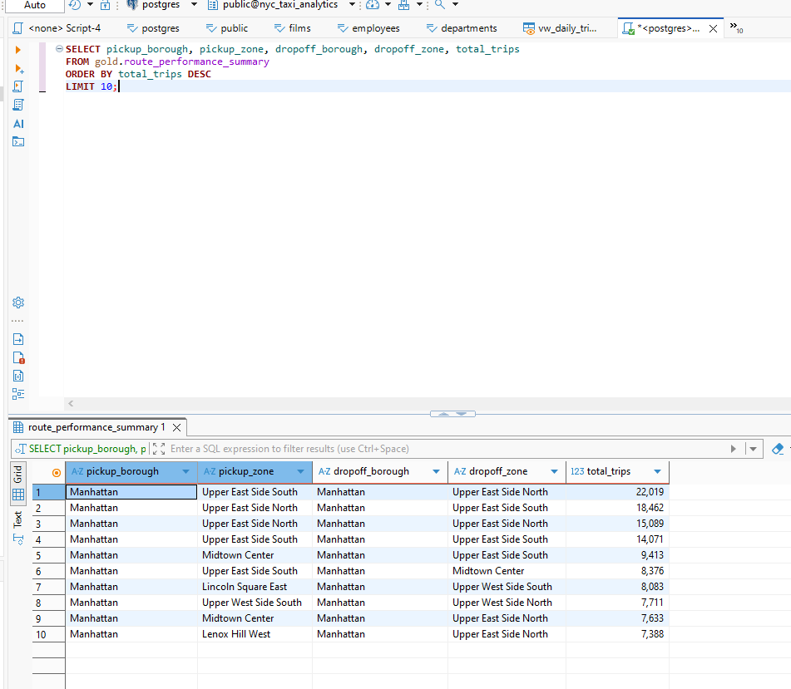
9. Hitung jumlah trip, revenue, dan average duration untuk setiap time period.
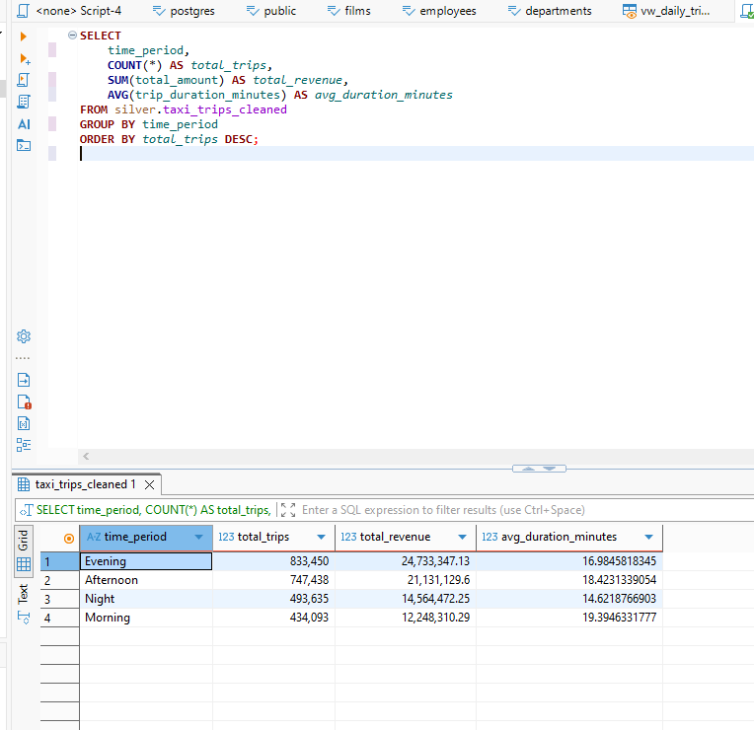
10. Tampilkan data quality issue terbanyak berdasarkan error_type.
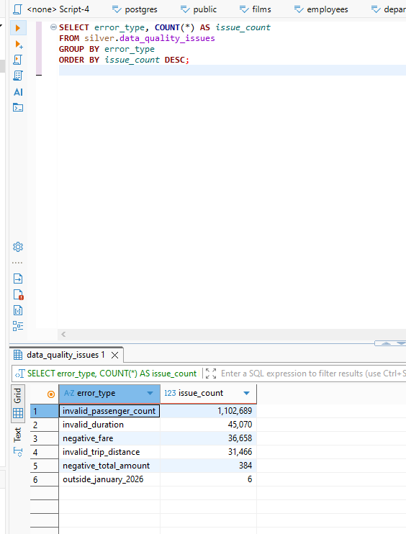
11. Cari tanggal atau jam dengan pola data tidak wajar, misalnya trip count sangat rendah/tinggi dibanding rata-rata.
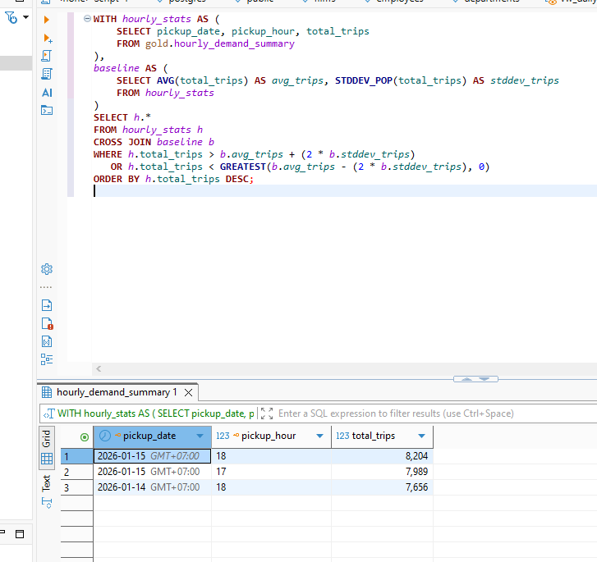

CTE, Subquery, dan Advanced Join

13. Top 10 pickup zone berdasarkan revenue.
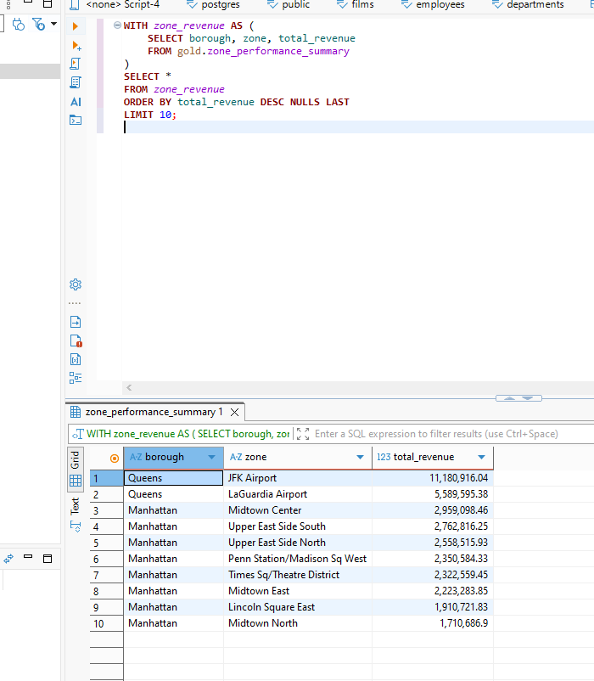
14. Zone yang memiliki pickup tinggi tetapi average tip rendah.
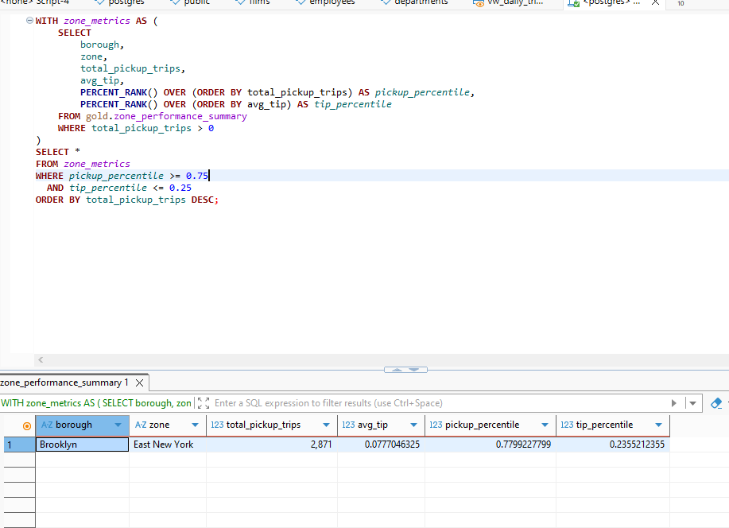
15. Perbandingan revenue setiap hari terhadap rata-rata revenue harian.
SELECT
pickup_date,
total_revenue,
AVG(total_revenue) OVER () AS avg_daily_revenue,
total_revenue - AVG(total_revenue) OVER () AS revenue_vs_average
FROM gold.daily_trip_summary
ORDER BY pickup_date
pickup_date | total_revenue | avg_daily_revenue | revenue_vs_average
2026-01-01 | 1,919,438.39 | 2,344,427.7183870968 | -424,989.3283870968
2026-01-02 | 2,197,842.91 | 2,344,427.7183870968 | -146,584.8083870968
2026-01-03 | 2,226,699.14 | 2,344,427.7183870968 | -117,728.5783870968
2026-01-04 | 2,016,390.03 | 2,344,427.7183870968 | -328,037.6883870968
2026-01-05 | 2,265,681.23 | 2,344,427.7183870968 | -78,746.4883870968
2026-01-06 | 2,372,292.68 | 2,344,427.7183870968 | 27,864.9616129032
2026-01-07 | 2,436,914.61 | 2,344,427.7183870968 | 92,486.8916129032
2026-01-08 | 2,623,042.71 | 2,344,427.7183870968 | 278,614.9916129032
2026-01-09 | 2,601,019.99 | 2,344,427.7183870968 | 256,592.2716129032
2026-01-10 | 2,502,000.09 | 2,344,427.7183870968 | 157,572.3716129032
2026-01-11 | 2,215,276.39 | 2,344,427.7183870968 | -129,151.3283870968
2026-01-12 | 2,422,017.18 | 2,344,427.7183870968 | 77,589.4616129032
2026-01-13 | 2,611,811.92 | 2,344,427.7183870968 | 267,384.2016129032
2026-01-14 | 2,747,142.08 | 2,344,427.7183870968 | 402,714.3616129032
2026-01-15 | 2,930,203.83 | 2,344,427.7183870968 | 585,776.1116129032
2026-01-16 | 2,683,757.12 | 2,344,427.7183870968 | 339,329.4016129032
2026-01-17 | 2,123,239.18 | 2,344,427.7183870968 | -221,188.5383870968
2026-01-18 | 1,918,388.7 | 2,344,427.7183870968 | -426,039.0183870968
2026-01-19 | 2,095,621.51 | 2,344,427.7183870968 | -248,806.2083870968
2026-01-20 | 2,680,231.57 | 2,344,427.7183870968 | 335,803.8516129032
2026-01-21 | 2,629,703.41 | 2,344,427.7183870968 | 285,275.6916129032
2026-01-22 | 2,800,923.57 | 2,344,427.7183870968 | 456,495.8516129032
2026-01-23 | 2,732,672.76 | 2,344,427.7183870968 | 388,245.0416129032
2026-01-24 | 2,219,094.37 | 2,344,427.7183870968 | -125,333.3483870968
2026-01-25 | 441,707.04 | 2,344,427.7183870968 | -1,902,720.6783870968
2026-01-26 | 1,190,436.09 | 2,344,427.7183870968 | -1,153,991.6283870968
2026-01-27 | 2,472,151.64 | 2,344,427.7183870968 | 127,723.9216129032
2026-01-28 | 2,723,838.88 | 2,344,427.7183870968 | 379,411.1616129032
2026-01-29 | 2,896,853.21 | 2,344,427.7183870968 | 552,425.4916129032
2026-01-30 | 2,753,631.56 | 2,344,427.7183870968 | 409,203.8416129032
2026-01-31 | 2,227,235.48 | 2,344,427.7183870968 | -117,192.2383870968

16. Trip dengan durasi di atas rata-rata durasi untuk zone yang sama.

17. Pickup borough yang tidak memiliki kontribusi revenue signifikan dibanding borough lain.
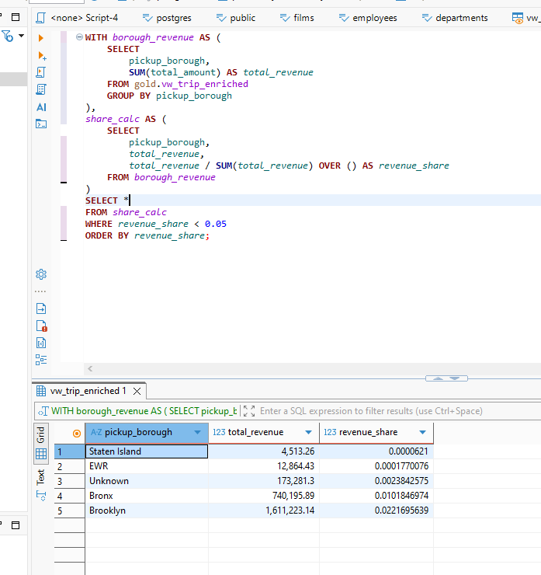

Ranking dan windowing
18. Ranking pickup zone berdasarkan total revenue.
ELECT
borough,
zone,
total_revenue,
RANK() OVER (ORDER BY total_revenue DESC NULLS LAST) AS revenue_rank
FROM gold.zone_performance_summary
borough | zone | total_revenue | revenue_rank
Queens | JFK Airport | 11,180,916.04 | 1
Queens | LaGuardia Airport | 5,589,595.38 | 2
Manhattan | Midtown Center | 2,959,098.46 | 3
Manhattan | Upper East Side South | 2,762,816.25 | 4
Manhattan | Upper East Side North | 2,558,515.93 | 5
Manhattan | Penn Station/Madison Sq West | 2,350,584.33 | 6
Manhattan | Times Sq/Theatre District | 2,322,559.45 | 7
Manhattan | Midtown East | 2,223,283.85 | 8
Manhattan | Lincoln Square East | 1,910,721.83 | 9
Manhattan | Midtown North | 1,710,686.9 | 10
Manhattan | East Chelsea | 1,648,728.6 | 11
Manhattan | Murray Hill | 1,633,405.52 | 12
Manhattan | Union Sq | 1,536,073.92 | 13
Manhattan | Upper West Side South | 1,504,823.71 | 14
Manhattan | Clinton East | 1,373,071.05 | 15
Manhattan | Lenox Hill West | 1,318,093.36 | 16
Manhattan | Lenox Hill East | 1,294,218.43 | 17
Manhattan | East Village | 1,261,385.71 | 18
Manhattan | Midtown South | 1,195,036.79 | 19
Manhattan | West Village | 1,147,413.26 | 20
Manhattan | Gramercy | 1,090,757.59 | 21
Manhattan | Upper West Side North | 1,048,744.51 | 22
Manhattan | Yorkville West | 1,034,907.74 | 23
Manhattan | West Chelsea/Hudson Yards | 1,031,635.79 | 24
Manhattan | Sutton Place/Turtle Bay North | 973,145.64 | 25
Manhattan | Garment District | 901,654.41 | 26
Manhattan | Flatiron | 837,884.7 | 27
Manhattan | Central Park | 836,576.13 | 28
Manhattan | TriBeCa/Civic Center | 794,325.91 | 29
Manhattan | Greenwich Village South | 779,538.86 | 30
Manhattan | Yorkville East | 756,200.96 | 31
Manhattan | Greenwich Village North | 756,155.82 | 32
Manhattan | Kips Bay | 649,165.04 | 33
Manhattan | UN/Turtle Bay South | 624,734.08 | 34
Manhattan | Lower East Side | 573,994.83 | 35
Manhattan | Lincoln Square West | 565,243.97 | 36
Manhattan | Little Italy/NoLiTa | 554,688.32 | 37
Manhattan | Meatpacking/West Village West | 450,431.56 | 38
Queens | East Elmhurst | 433,168 | 39
Manhattan | Battery Park City | 419,400.99 | 40
Manhattan | SoHo | 407,857.4 | 41
Manhattan | Manhattan Valley | 397,308.54 | 42
Manhattan | East Harlem South | 378,995.72 | 43
Manhattan | Financial District North | 344,601.57 | 44
Manhattan | World Trade Center | 314,146.51 | 45
Manhattan | Hudson Sq | 270,119.7 | 46
Manhattan | Clinton West | 260,257.04 | 47
Manhattan | Morningside Heights | 228,699.29 | 48
Manhattan | Financial District South | 214,230.12 | 49
Manhattan | Central Harlem | 153,903.88 | 50
Manhattan | East Harlem North | 147,996.49 | 51
Queens | South Ozone Park | 129,830.08 | 52
Manhattan | Bloomingdale | 127,632.36 | 53
Manhattan | Central Harlem North | 119,210.84 | 54
Queens | Sunnyside | 117,221.11 | 55
Unknown | Unknown | 115,309.67 | 56
Manhattan | Chinatown | 105,577.15 | 57
Brooklyn | East New York | 104,649.97 | 58
Manhattan | Seaport | 104,494.98 | 59
Manhattan | Alphabet City | 95,326.06 | 60
Queens | Baisley Park | 87,319.51 | 61
Queens | Long Island City/Hunters Point | 80,436.98 | 62
Manhattan | Two Bridges/Seward Park | 80,340.05 | 63
Brooklyn | Crown Heights North | 75,728.25 | 64
Manhattan | Washington Heights South | 73,255.58 | 65
Brooklyn | Canarsie | 64,443.14 | 66
Queens | Jackson Heights | 58,601.28 | 67
Unknown | Outside of NYC | 57,971.63 | 68
Brooklyn | Brownsville | 57,268.36 | 69
Manhattan | Stuy Town/Peter Cooper Village | 56,499.22 | 70
Queens | Jamaica | 56,276.49 | 71
Manhattan | Hamilton Heights | 53,707.73 | 72
Brooklyn | Flatbush/Ditmas Park | 53,184.69 | 73
Brooklyn | Coney Island | 51,747.41 | 74
Brooklyn | Prospect-Lefferts Gardens | 51,613.66 | 75
Brooklyn | Fort Greene | 50,657.68 | 76
Queens | Richmond Hill | 48,459.64 | 77
Brooklyn | Downtown Brooklyn/MetroTech | 47,159.6 | 78
Queens | Steinway | 46,354.88 | 79
Brooklyn | Stuyvesant Heights | 45,766.56 | 80
Queens | South Jamaica | 45,176.86 | 81
Brooklyn | Flatlands | 44,946.06 | 82
Queens | Hammels/Arverne | 44,787.02 | 83
Bronx | Co-Op City | 44,392.03 | 84
Queens | Springfield Gardens South | 44,297.7 | 85
Queens | Far Rockaway | 42,892.81 | 86
Brooklyn | Brooklyn Heights | 41,809.71 | 87
Brooklyn | East Flatbush/Remsen Village | 39,194.15 | 88
Queens | Astoria | 37,878.95 | 89
Brooklyn | Ocean Hill | 37,691.64 | 90
Bronx | Williamsbridge/Olinville | 37,261.59 | 91
Brooklyn | Boerum Hill | 36,672.12 | 92
Bronx | East Concourse/Concourse Village | 36,582.63 | 93
Queens | Saint Albans | 34,850.96 | 94
Brooklyn | Bedford | 34,458.29 | 95
Brooklyn | East Flatbush/Farragut | 34,438.34 | 96
Brooklyn | Bay Ridge | 34,304.94 | 97
Brooklyn | Bushwick South | 34,238.03 | 98
Bronx | Soundview/Castle Hill | 33,798.11 | 99
Brooklyn | Park Slope | 33,133.12 | 100
Brooklyn | Starrett City | 32,986.66 | 101
Manhattan | Manhattanville | 32,943.11 | 102
Brooklyn | DUMBO/Vinegar Hill | 32,748.33 | 103
Queens | Long Island City/Queens Plaza | 32,555.77 | 104
Queens | Woodside | 32,128.89 | 105
Queens | Forest Hills | 31,585.28 | 106
Bronx | Parkchester | 31,507.96 | 107
Bronx | Mott Haven/Port Morris | 31,455.23 | 108
Brooklyn | Clinton Hill | 31,114.07 | 109
Brooklyn | East Williamsburg | 29,919.05 | 110
Queens | Springfield Gardens North | 29,388.02 | 111
Bronx | University Heights/Morris Heights | 28,882.61 | 112
Brooklyn | Red Hook | 28,604.93 | 113
Brooklyn | Sheepshead Bay | 28,578.24 | 114
Brooklyn | East New York/Pennsylvania Avenue | 28,277.08 | 115
Manhattan | Washington Heights North | 28,060.81 | 116
Bronx | East Tremont | 27,460.06 | 117
Bronx | Melrose South | 26,927.03 | 118
Queens | Flushing Meadows-Corona Park | 26,390.5 | 119
Brooklyn | Williamsburg (South Side) | 25,784.4 | 120
Bronx | Bedford Park | 24,798.14 | 121
Queens | Queens Village | 24,774.76 | 122
Queens | Kew Gardens | 24,539.99 | 123
Queens | Briarwood/Jamaica Hills | 24,287.35 | 124
Brooklyn | Crown Heights South | 24,004.13 | 125
Queens | Elmhurst | 23,396.46 | 126
Bronx | Morrisania/Melrose | 23,369.41 | 127
Brooklyn | Williamsburg (North Side) | 22,770.32 | 128
Bronx | Woodlawn/Wakefield | 22,259.59 | 129
Bronx | West Concourse | 22,074.28 | 130
Bronx | Norwood | 22,048.71 | 131
Brooklyn | Sunset Park West | 21,240.3 | 132
Bronx | Van Cortlandt Village | 20,951.76 | 133
Queens | Corona | 20,898.48 | 134
Brooklyn | Midwood | 20,707.4 | 135
Brooklyn | Marine Park/Mill Basin | 20,210.01 | 136
Brooklyn | Brighton Beach | 19,135.74 | 137
Queens | Flushing | 19,099.24 | 138
Bronx | Highbridge | 18,962.73 | 139
Bronx | Claremont/Bathgate | 18,884.94 | 140
Queens | Maspeth | 18,757.09 | 141
Queens | Old Astoria | 18,552.84 | 142
Bronx | Eastchester | 18,408.42 | 143
Queens | Rosedale | 18,237.68 | 144
Bronx | Van Nest/Morris Park | 18,184.89 | 145
Brooklyn | Erasmus | 18,120.94 | 146
Brooklyn | Bensonhurst West | 17,948.34 | 147
Brooklyn | Cypress Hills | 17,882.52 | 148
Brooklyn | Homecrest | 17,674.27 | 149
Queens | Laurelton | 17,613.35 | 150
Bronx | Mount Hope | 17,499.27 | 151
Brooklyn | Borough Park | 17,449.85 | 152
Queens | Queensbridge/Ravenswood | 17,310.02 | 153
Manhattan | Inwood | 17,268.79 | 154
Bronx | Bronxdale | 17,093.51 | 155
Queens | Rego Park | 16,701.24 | 156
Brooklyn | Greenpoint | 16,570.55 | 157
Bronx | Spuyten Duyvil/Kingsbridge | 16,412.61 | 158
Brooklyn | Gravesend | 15,814.63 | 159
Bronx | Pelham Parkway | 15,764.28 | 160
Manhattan | Battery Park | 15,539.32 | 161
Bronx | Westchester Village/Unionport | 15,195.52 | 162
Bronx | Kingsbridge Heights | 15,053.25 | 163
Queens | Hillcrest/Pomonok | 14,881.2 | 164
Brooklyn | Bensonhurst East | 14,816.37 | 165
Brooklyn | Bushwick North | 14,444.86 | 166
Queens | Cambria Heights | 14,263.53 | 167
Bronx | Crotona Park East | 13,441.22 | 168
Queens | Elmhurst/Maspeth | 13,108.58 | 169
Bronx | West Farms/Bronx River | 12,922.51 | 170
EWR | Newark Airport | 12,864.43 | 171
Queens | Woodhaven | 12,742.16 | 172
Queens | Howard Beach | 12,655.65 | 173
Bronx | Allerton/Pelham Gardens | 12,622.63 | 174
Brooklyn | Madison | 12,559.64 | 175
Brooklyn | Prospect Heights | 12,388.87 | 176
Bronx | Hunts Point | 12,167.28 | 177
Bronx | Longwood | 12,005.78 | 178
Bronx | Schuylerville/Edgewater Park | 11,974.57 | 179
Bronx | Soundview/Bruckner | 11,827.34 | 180
Manhattan | Roosevelt Island | 11,684.46 | 181
Bronx | Fordham South | 11,492.57 | 182
Brooklyn | Sunset Park East | 11,440.64 | 183
Brooklyn | Cobble Hill | 11,012.84 | 184
Bronx | Belmont | 10,856.36 | 185
Queens | Rockaway Park | 10,608.72 | 186
Queens | Ridgewood | 10,478.5 | 187
Bronx | Riverdale/North Riverdale/Fieldston | 10,409.17 | 188
Queens | Jamaica Estates | 10,241.48 | 189
Queens | Saint Michaels Cemetery/Woodside | 10,179.01 | 190
Queens | Hollis | 8,560.3 | 191
Brooklyn | South Williamsburg | 8,492.19 | 192
Brooklyn | Kensington | 8,288.33 | 193
Queens | Kew Gardens Hills | 8,088.3 | 194
Queens | Bellerose | 7,934.15 | 195
Brooklyn | Manhattan Beach | 7,827.22 | 196
Queens | Middle Village | 7,699.58 | 197
Queens | Ozone Park | 7,608.29 | 198
Brooklyn | Carroll Gardens | 7,217.94 | 199
Brooklyn | Dyker Heights | 7,094.57 | 200
Brooklyn | Bath Beach | 6,968.55 | 201
Manhattan | Randalls Island | 6,819.94 | 202
Brooklyn | Gowanus | 6,553.59 | 203
Queens | Murray Hill-Queens | 6,217.96 | 204
Queens | Bayside | 6,111.69 | 205
Brooklyn | Windsor Terrace | 5,858.29 | 206
Queens | Glen Oaks | 5,652.7 | 207
Queens | Whitestone | 5,486.32 | 208
Queens | Glendale | 5,407.89 | 209
Bronx | Pelham Bay | 5,262.78 | 210
Queens | College Point | 5,211.22 | 211
Queens | Fresh Meadows | 4,933.83 | 212
Manhattan | Marble Hill | 4,856.97 | 213
Brooklyn | Ocean Parkway South | 4,831.39 | 214
Queens | North Corona | 4,300.92 | 215
Queens | Queensboro Hill | 3,885.71 | 216
Queens | Bay Terrace/Fort Totten | 3,747.29 | 217
Bronx | Van Cortlandt Park | 3,685.98 | 218
Brooklyn | Brooklyn Navy Yard | 3,537.51 | 219
Queens | Oakland Gardens | 3,312.86 | 220
Queens | Auburndale | 3,230.24 | 221
Brooklyn | Prospect Park | 2,819.47 | 222
Queens | Douglaston | 2,550.67 | 223
Manhattan | Inwood Hill Park | 2,536.39 | 224
Queens | East Flushing | 2,367.34 | 225
Brooklyn | Marine Park/Floyd Bennett Field | 2,252.5 | 226
Queens | Forest Park/Highland Park | 2,213.99 | 227
Brooklyn | Columbia Street | 1,951.84 | 228
Bronx | Bronx Park | 1,580.29 | 229
Bronx | City Island | 1,530.83 | 230
Bronx | Country Club | 1,446.09 | 231
Queens | Astoria Park | 1,121.02 | 232
Bronx | Crotona Park | 926.46 | 233
Manhattan | Highbridge Park | 829.66 | 234
Staten Island | Bloomfield/Emerson Hill | 780.71 | 235
Queens | Corona | 680.48 | 236
Staten Island | Arrochar/Fort Wadsworth | 589.34 | 237
Bronx | Pelham Bay Park | 564.08 | 238
Queens | Willets Point | 419.8 | 239
Staten Island | Westerleigh | 407.09 | 240
Staten Island | Stapleton | 398.37 | 241
Staten Island | Saint George/New Brighton | 385.85 | 242
Staten Island | South Beach/Dongan Hills | 364.63 | 243
Bronx | Rikers Island | 251.39 | 244
Staten Island | Mariners Harbor | 220.31 | 245
Brooklyn | Green-Wood Cemetery | 219.05 | 246
Queens | Jamaica Bay | 193.81 | 247
Staten Island | New Dorp/Midland Beach | 189.15 | 248
Staten Island | Port Richmond | 187 | 249
Staten Island | Great Kills | 180.12 | 250
Queens | Breezy Point/Fort Tilden/Riis Beach | 174.23 | 251
Staten Island | Oakwood | 164.6 | 252
Staten Island | Heartland Village/Todt Hill | 161.82 | 253
Staten Island | Eltingville/Annadale/Prince's Bay | 144.77 | 254
Staten Island | Freshkills Park | 124 | 255
Manhattan | Governor's Island/Ellis Island/Liberty Island | 120.84 | 256
Queens | Broad Channel | 106.46 | 257
Staten Island | Grymes Hill/Clifton | 89 | 258
Staten Island | Arden Heights | 77.5 | 259
Staten Island | West Brighton | 49 | 260
Staten Island | Charleston/Tottenville |  | 261
Staten Island | Great Kills Park |  | 261
Manhattan | Governor's Island/Ellis Island/Liberty Island |  | 261
Manhattan | Governor's Island/Ellis Island/Liberty Island |  | 261
Staten Island | Rossville/Woodrow |  | 261

19. Ranking pickup zone per borough.
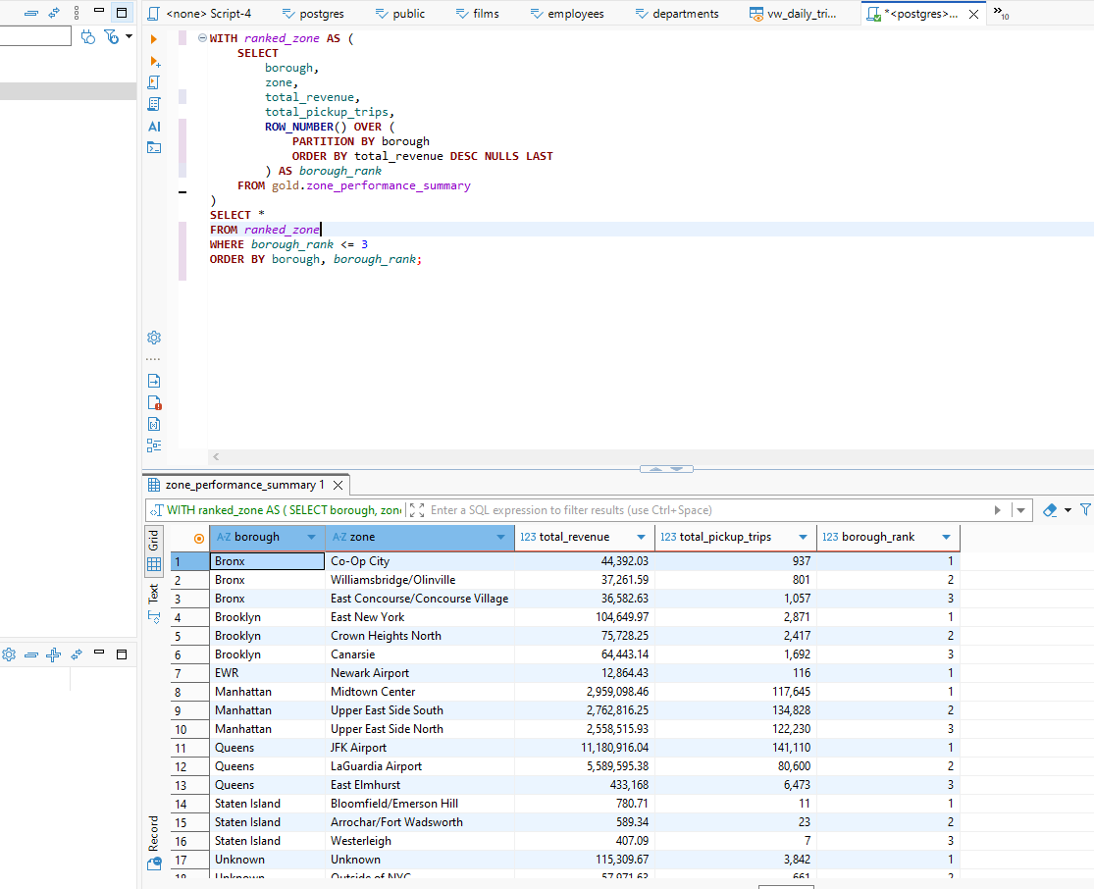
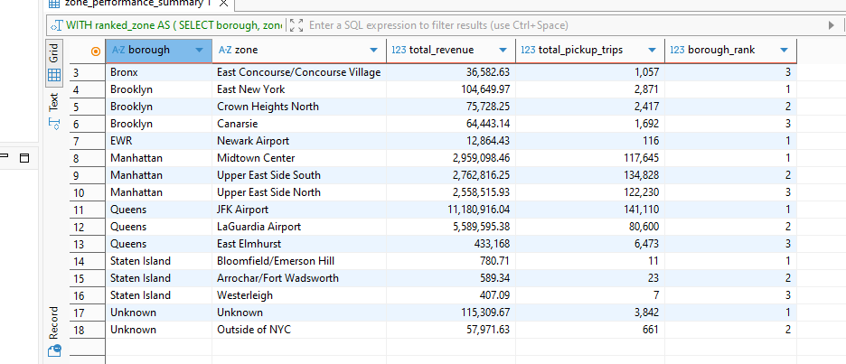
20. Running total revenue per tanggal.
SELECT
pickup_date,
total_revenue,
SUM(total_revenue) OVER (ORDER BY pickup_date) AS running_total_revenue
FROM gold.daily_trip_summary
ORDER BY pickup_date
pickup_date | total_revenue | running_total_revenue
2026-01-01 | 1,919,438.39 | 1,919,438.39
2026-01-02 | 2,197,842.91 | 4,117,281.3
2026-01-03 | 2,226,699.14 | 6,343,980.44
2026-01-04 | 2,016,390.03 | 8,360,370.47
2026-01-05 | 2,265,681.23 | 10,626,051.7
2026-01-06 | 2,372,292.68 | 12,998,344.38
2026-01-07 | 2,436,914.61 | 15,435,258.99
2026-01-08 | 2,623,042.71 | 18,058,301.7
2026-01-09 | 2,601,019.99 | 20,659,321.69
2026-01-10 | 2,502,000.09 | 23,161,321.78
2026-01-11 | 2,215,276.39 | 25,376,598.17
2026-01-12 | 2,422,017.18 | 27,798,615.35
2026-01-13 | 2,611,811.92 | 30,410,427.27
2026-01-14 | 2,747,142.08 | 33,157,569.35
2026-01-15 | 2,930,203.83 | 36,087,773.18
2026-01-16 | 2,683,757.12 | 38,771,530.3
2026-01-17 | 2,123,239.18 | 40,894,769.48
2026-01-18 | 1,918,388.7 | 42,813,158.18
2026-01-19 | 2,095,621.51 | 44,908,779.69
2026-01-20 | 2,680,231.57 | 47,589,011.26
2026-01-21 | 2,629,703.41 | 50,218,714.67
2026-01-22 | 2,800,923.57 | 53,019,638.24
2026-01-23 | 2,732,672.76 | 55,752,311
2026-01-24 | 2,219,094.37 | 57,971,405.37
2026-01-25 | 441,707.04 | 58,413,112.41
2026-01-26 | 1,190,436.09 | 59,603,548.5
2026-01-27 | 2,472,151.64 | 62,075,700.14
2026-01-28 | 2,723,838.88 | 64,799,539.02
2026-01-29 | 2,896,853.21 | 67,696,392.23
2026-01-30 | 2,753,631.56 | 70,450,023.79
2026-01-31 | 2,227,235.48 | 72,677,259.27

21. Moving average trip count 7 hari.
SELECT
pickup_date,
total_trips,
AVG(total_trips) OVER (
ORDER BY pickup_date
ROWS BETWEEN 6 PRECEDING AND CURRENT ROW
) AS moving_avg_trip_7d
FROM gold.daily_trip_summary
ORDER BY pickup_date
pickup_date | total_trips | moving_avg_trip_7d
2026-01-01 | 62,828 | 62,828
2026-01-02 | 71,922 | 67,375
2026-01-03 | 75,497 | 70,082.3333333333
2026-01-04 | 63,361 | 68,402
2026-01-05 | 73,232 | 69,368
2026-01-06 | 81,744 | 71,430.6666666667
2026-01-07 | 85,313 | 73,413.8571428571
2026-01-08 | 90,230 | 77,328.4285714286
2026-01-09 | 90,666 | 80,006.1428571429
2026-01-10 | 93,846 | 82,627.4285714286
2026-01-11 | 76,566 | 84,513.8571428571
2026-01-12 | 83,234 | 85,942.7142857143
2026-01-13 | 91,033 | 87,269.7142857143
2026-01-14 | 96,452 | 88,861
2026-01-15 | 102,732 | 90,647
2026-01-16 | 93,417 | 91,040
2026-01-17 | 81,367 | 89,257.2857142857
2026-01-18 | 70,644 | 88,411.2857142857
2026-01-19 | 67,427 | 86,153.1428571429
2026-01-20 | 92,448 | 86,355.2857142857
2026-01-21 | 93,718 | 85,964.7142857143
2026-01-22 | 98,762 | 85,397.5714285714
2026-01-23 | 99,103 | 86,209.8571428571
2026-01-24 | 86,671 | 86,967.5714285714
2026-01-25 | 17,570 | 79,385.5714285714
2026-01-26 | 38,583 | 75,265
2026-01-27 | 75,830 | 72,891
2026-01-28 | 85,827 | 71,763.7142857143
2026-01-29 | 92,560 | 70,877.7142857143
2026-01-30 | 91,561 | 69,800.2857142857
2026-01-31 | 84,472 | 69,486.1428571429

22. Perbandingan revenue hari ini dengan hari sebelumnya menggunakan LAG.
SELECT
pickup_date,
total_revenue,
LAG(total_revenue) OVER (ORDER BY pickup_date) AS previous_day_revenue,
total_revenue - LAG(total_revenue) OVER (ORDER BY pickup_date) AS revenue_delta
FROM gold.daily_trip_summary
ORDER BY pickup_date
pickup_date | total_revenue | previous_day_revenue | revenue_delta
2026-01-01 | 1,919,438.39
2026-01-02 | 2,197,842.91 | 1,919,438.39 | 278,404.52
2026-01-03 | 2,226,699.14 | 2,197,842.91 | 28,856.23
2026-01-04 | 2,016,390.03 | 2,226,699.14 | -210,309.11
2026-01-05 | 2,265,681.23 | 2,016,390.03 | 249,291.2
2026-01-06 | 2,372,292.68 | 2,265,681.23 | 106,611.45
2026-01-07 | 2,436,914.61 | 2,372,292.68 | 64,621.93
2026-01-08 | 2,623,042.71 | 2,436,914.61 | 186,128.1
2026-01-09 | 2,601,019.99 | 2,623,042.71 | -22,022.72
2026-01-10 | 2,502,000.09 | 2,601,019.99 | -99,019.9
2026-01-11 | 2,215,276.39 | 2,502,000.09 | -286,723.7
2026-01-12 | 2,422,017.18 | 2,215,276.39 | 206,740.79
2026-01-13 | 2,611,811.92 | 2,422,017.18 | 189,794.74
2026-01-14 | 2,747,142.08 | 2,611,811.92 | 135,330.16
2026-01-15 | 2,930,203.83 | 2,747,142.08 | 183,061.75
2026-01-16 | 2,683,757.12 | 2,930,203.83 | -246,446.71
2026-01-17 | 2,123,239.18 | 2,683,757.12 | -560,517.94
2026-01-18 | 1,918,388.7 | 2,123,239.18 | -204,850.48
2026-01-19 | 2,095,621.51 | 1,918,388.7 | 177,232.81
2026-01-20 | 2,680,231.57 | 2,095,621.51 | 584,610.06
2026-01-21 | 2,629,703.41 | 2,680,231.57 | -50,528.16
2026-01-22 | 2,800,923.57 | 2,629,703.41 | 171,220.16
2026-01-23 | 2,732,672.76 | 2,800,923.57 | -68,250.81
2026-01-24 | 2,219,094.37 | 2,732,672.76 | -513,578.39
2026-01-25 | 441,707.04 | 2,219,094.37 | -1,777,387.33
2026-01-26 | 1,190,436.09 | 441,707.04 | 748,729.05
2026-01-27 | 2,472,151.64 | 1,190,436.09 | 1,281,715.55
2026-01-28 | 2,723,838.88 | 2,472,151.64 | 251,687.24
2026-01-29 | 2,896,853.21 | 2,723,838.88 | 173,014.33
2026-01-30 | 2,753,631.56 | 2,896,853.21 | -143,221.65
2026-01-31 | 2,227,235.48 | 2,753,631.56 | -526,396.08

23. Ambil top 3 pickup zone untuk setiap borough menggunakan ROW_NUMBER, RANK, atau DENSE_RANK.
WITH ranked_zones AS (
SELECT
borough,
zone,
total_pickup_trips,
total_revenue,
ROW_NUMBER() OVER (
PARTITION BY borough
ORDER BY total_pickup_trips DESC, total_revenue DESC
) AS zone_rank
FROM gold.zone_performance_summary
WHERE total_pickup_trips > 0
)
SELECT
borough,
zone,
total_pickup_trips,
total_revenue,
zone_rank
FROM ranked_zones
WHERE zone_rank <= 3
ORDER BY borough, zone_rank
borough | zone | total_pickup_trips | total_revenue | zone_rank
Bronx | East Concourse/Concourse Village | 1,057 | 36,582.63 | 1
Bronx | Co-Op City | 937 | 44,392.03 | 2
Bronx | Mott Haven/Port Morris | 919 | 31,455.23 | 3
Brooklyn | East New York | 2,871 | 104,649.97 | 1
Brooklyn | Crown Heights North | 2,417 | 75,728.25 | 2
Brooklyn | Fort Greene | 1,713 | 50,657.68 | 3
EWR | Newark Airport | 116 | 12,864.43 | 1
Manhattan | Upper East Side South | 134,828 | 2,762,816.25 | 1
Manhattan | Upper East Side North | 122,230 | 2,558,515.93 | 2
Manhattan | Midtown Center | 117,645 | 2,959,098.46 | 3
Queens | JFK Airport | 141,110 | 11,180,916.04 | 1
Queens | LaGuardia Airport | 80,600 | 5,589,595.38 | 2
Queens | East Elmhurst | 6,473 | 433,168 | 3
Staten Island | Arrochar/Fort Wadsworth | 23 | 589.34 | 1
Staten Island | Bloomfield/Emerson Hill | 11 | 780.71 | 2
Staten Island | Westerleigh | 7 | 407.09 | 3
Unknown | Unknown | 3,842 | 115,309.67 | 1
Unknown | Outside of NYC | 661 | 57,971.63 | 2

